

**2018 SOA Bellagos Case Competition**

**Team Five Xueba**

**Dongyang Zhao**

**Yuxuan Tao**

**Zhijun Sun**

**Yizhou Xuan**

**Jingyi Han**

**Contents**

1. **Introduction (page 3-4)**
   1. Background Summary
   2. Problem analyzing
2. **Data Limitation (page 5-6)** 
   1. Incomplete population information
   2. Discontinuous dataset of mortality rate
   3. Assumptions
3. **Model Description (page 7-21)**
   1. Sample analysis
   2. Data prediction method
      1. Mortality rate
      2. Fertility rate
      3. Number of people above 65 years old
      4. Calculate the number of people in each care level
      5. Estimate the payout for each care level and tax contribution to the system
      6. Estimate the number of caregiver and percentage of informal caregiver
      7. Population analysis
4. **Data Analysis (page 22-29)**
   1. Data analysis
   2. Recommendations and trade-offs
5. **Appendices (page30-32)**
   1. Citations
   2. R code and screenshots
6. **Introduction**
   1. **Background summary**

Bellagos is a country with a stable economy and population. Starting March ~~of~~ 1998, the Social LTC Insurance Program introduced by the government of Bellagos was selected by the majority of Bellagos citizens as there was no strong supplementary insurance program available. In recent years, there has been a fluctuation of the demographics in the country~~.~~ such that participation in the program has declined. Therefore, the government decided to make improvements in their program. One significant change was to employ actuarial professionals. The purpose of this report is to analyze that decision. The analysis will be conducted along two lines:

1. Holistically study the current situation of the country’s social insurance program.

2. Make recommendations for future actions regarding future population and economic trends.

This study develops an approach to meet the needs of the citizens in the future. There are five actuarial students in our group doing research and building models to predict the changes in population receiving home care benefits, facility care benefits, mortality rate, and fertility rate to help the program better fit the needs in the future. Considering the size of the sample and the number of variants included in the sample, we decided to use Excel, Access, and Java to analyze the database with respect to the two goals above.

* 1. **Problem analyzing**

The sustainability is affected by two most important points: the benefit level and number of people in the system. So, it’s important for us to figure out the trend of population, benefit payout and percentage of people in the system.

1. **Data Limitation**
   1. **Incomplete population information**

From the data provided in HH records data sheet, it can be analyzed that the age range of women getting pregnant is 18 to 32. In fact, a research showed that women who beyond 35 also can get pregnant(Sifferlin,2014). This part of data is used to estimate the birth rate in the next decade, however, the crowd coverage of HH records is not wide enough. Therefore, the estimated birth rate may not be accurate.

* 1. **Discontinuous dataset of mortality rate**

The Bellagos government only provided mortality rate data of 2005,2010 and 2015, rather than for each year. Although the overall trends of mortality rate can be predicted by linear regression model, the minor errors exist due to the discontinuous dataset of mortality rate. Hence, the lack of mortality rate during those 10 years may affect the accuracy of estimated mortality rate.

* 1. **Assumptions**

There are three assumptions used in the analyzing:

* In the Care Level Transition Matrix sheet, it shows that mortality rate from care levels can be assumed to be 3 times the general population mortality rate. Actually, the relationship between the mortality rate of general population and people in LTC program cannot be estimated precisely
* In order to easily estimate the mortality rate, we assume that the percent of the unhealthy and healthy people with the same sex beyond 65 years-old are same. However, the percentage could not be exactly same in the real situation. Hence, there will be minor error of estimated mortality rate, but it could not change the overall trend.
* An assumption used to calculate and estimate the tax collection was came up: the tax rate always be same.

1. **Model Description**
   1. **Sample analysis**

By using Java and access, we get the following information from the HH record data.

1. The sample is comprised of 10000 households with 20797 individuals including 10362 females and 10435 males.

2.

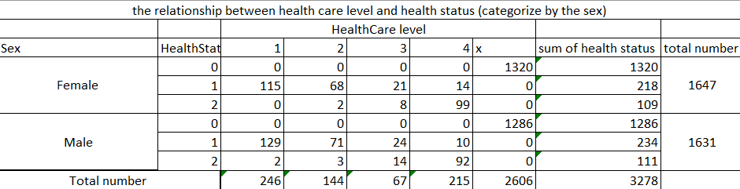

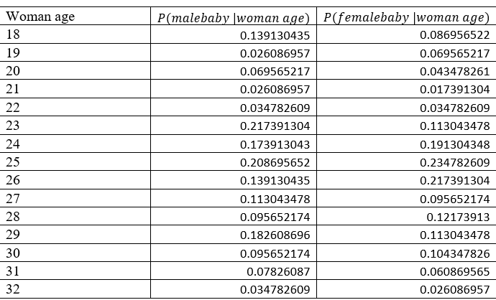 3.age-specific birth rate schedule.

* 1. **Data prediction method**

3.2.1 Mortality rate

The death rate will be different between male and female, so we predict the death rate separately. We assume the death rate will affect by the year and age of female (or male). By using the multiple linear regression method, we tried to find out the best model to predict the mortality rate for the next few years. Looking at the data, we find out the mortality rates for the 0 and above 110 years old male (female) is out of trend. So, we build the different model for the different age.

(1) age 1-109

According to our findings and analyzing, we fit the model with following multiple linear regression line for the male (female) between age 1 and age 109.

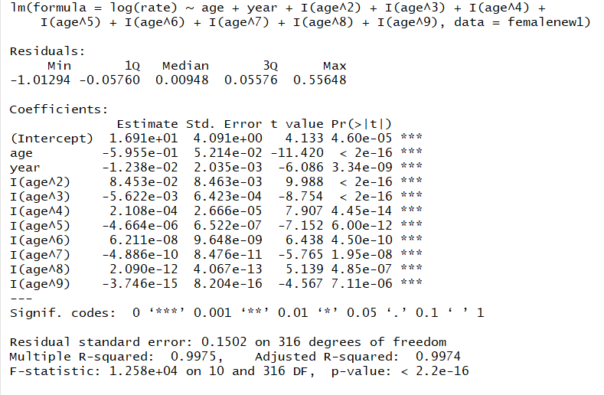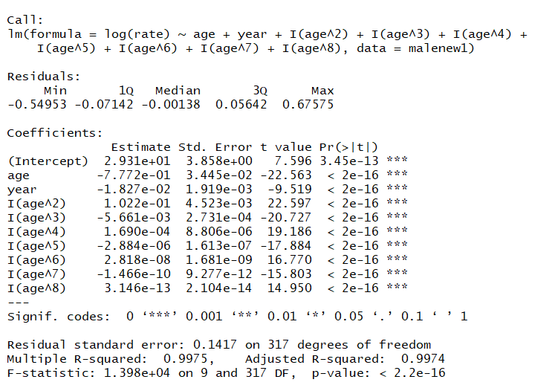 According to the summary function, we get the following R result.

Since both models give us a really high r-square value, and P value for each coefficient is quite small, we believe these two models can best represent the mortality rate under the effect of age (between 1 and 109) and the year for the next decade.

(2) age 0

We think out the death rate for the age 0 will affect by the year. We fill out the multiple linear regression model for them and get the following result.

However, since we only have 3 data for age 0 each gender. So, we assume this model will work for whole population.

(3) 110+

According to the trend from 2005 to the 2015, the death rates for 2005, 2010 and 2015 are all 1. So, we believe this trend will continue for the following decade.

3.2.2 Fertility rate

To estimate the fertility rate, we assume the birth situation will be the same for next decade, meaning the age- specific birth rate schedule for woman can estimate the birth number for next decade.

 We use the sampling result to estimate our age-specific birth rate schedule for woman. By analyzing the sample data, we get the following age-specific birth rate schedule.

The total number of baby next year will be

)

3.2.3 Number of People above 65 years old

The number of people above 65 years old will compose the people who still survive from the last year and the new people who is 65 years-old this year. Since the death rate above 65 is different for the people who receive the LTC benefits and people who is out of LTC benefits. So, the total population above 65 can be estimated by the following equation.

represents the number of female receiving the LTC at the age of xx in the year xxxx.

If the 3 times of mortality rate larger than 1, we will just use 1 instead.

3.2.4 Calculate the number of people in each care level

From the HH record chart, we counted and extracted the amount of people in each category and created a chart showing those numbers.

To estimate the data under the condition of being in this policy in 2017 based on what we got from the chat of “relationship between health care level and health status (categorized by the sex)” showed below.

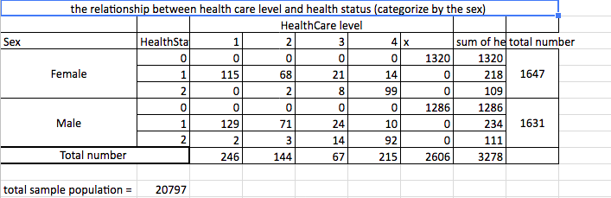

P: expresses the probability

L: HealthCare Level

S: HealthStatus

The conditional probability of people who are healthcare level 1 given they are health status 1 is P(L1|S1). To calculate the probability of P(L1|S1) in 2017, we use the formula

P(L1|S1)=

In the same way, we can get

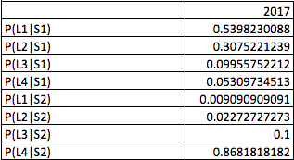

To estimate the rate for the following year, we need to calculate the number of people at each care level and total number of people at each heath status.

Therefore, next, we calculated the percentage of population in different HealthStatus. For example, P(S1) shows the percentage of people in HealthStatus 1 in the total population.

P(S1|population) =

In the same way, we can find out P(S2) as below:



To find out P(S0) we need to find out the percentage of people over 65 years old in population by using formula:

Since we know the total population from the historical data, we can calculate the estimate number of people above 65.

Number of people >65=0.15761883806360000127097565.99512709.7566K



Then we need to find out the number of people get to 65 years old next year.

From the sample data, we got there are 159 who is at age of 64. we can use this percentage to calculate the total number of people in Bellagos who are 64 years old:

Total number=Percentagetotal population=6164891 =6164.891K

Since there are 136 of 64-year old people qualified to get benefits at age of 65, we can get the total number of people at age of 64 who are qualified in the Bellagos population:

P(qualified to receive 65/age =64)=

Amount of people who qualified to receive at 65 =0.85534591196164.891K

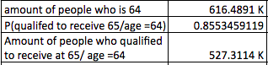

We can get the number of people in each category by using formula

M=1,2,3,4 n=1,2

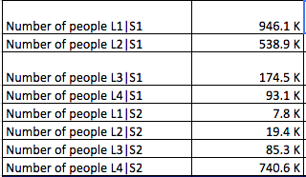

We still need the following information.

(1) Total amount of people who is 64 and will receive the health care benefit next year:

(2) Healthy over age of 65

(3) Number of people in each health status

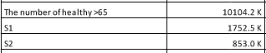

(4) The conditional probability of people in the HealthStatus 1 given the HealthCare level 1 is P(S1|L1). We can use the Baye’s theorem to calculate it.

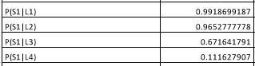

The new is composed 4 parts. According to the Bellagos Care Level Transition Matrix for Age 65+, the new

\**Related transition rate:*

*Getting from the matrix. For example, if we want to calculate the number of people becomes who is last year, we get rate is 0.15.*

*\*:*

*The number who is health last year but becomes this year which we can calculate according to the rate getting from the matrix.*

*\**

*\*EstimateNumberOfDied*

*The estimate number of died is calculated according to the formula*

*If 3* death rate is larger than 1, we use 1 instead of 3*deathrate.*

After we know the new number for equal level and health status, we can calculate the new by using the method we used at the beginning. And then we will repeat the whole process several times to get prediction results.

3.2.5 Estimate the payout for each care level and estimate tax contribution to the system

**Estimate payout**: we find out the average payout for each care level is increasing. So, we use the predict function in the excel to estimate the payout for future.

**Tax contribution**: tax contribution will fluctuate as the change of real wage.

3.2.6 Estimate number of caregiver and percentage of informal caregiver

We used the linear regression line to predict the future value for each part.

3.2.7 Population analysis

From the sample, we can get the population distribution for male and female by counting the number of people in each age level. Then we can get the approximate number of people by multiplying the counting number /sample population*total population.

So, we can approximate each age level by using the formula.

The number of birth get from the fertility rate.

And mortality situation is different above 65 years old. So, we can use conditional method to estimate.

If 3 * Mortality rate is larger than 1, then we use 1 instead of 3*mortality rate.

1. **Data Analysis**
   1. **Data analysis**

(1) Population trend

According to our model, we find out the total population is smoothly increasing. The number of people above 65 is decreasing initially, after several years back to increasing trend. We think that’s caused by the decreasing number of people above 80. Due to that, we estimate the number of people who need the LTC system will decrease at the first few years, then increase.

(b) health care level analysis

From these graphs, we can conclude that number of people receiving the homecare will increase, and the number of people receiving the facility care will decrease. This phenomenon happen may cause by more and more people tend to receive the care at home. According to the Statistic on Public Opinion, 93 percent of citizens wish to stay autonomous in their home for as long as possible and do not wish to live  
in a facility.

Series 1: receiving care level 1

Series 2: receiving care level 2

Series 3: receiving care level 3

Series 4: receiving care level 4

(c) Number of caregivers

(d) Estimate percent of people choosing the private LTC

(c) Government spending and contribution tax receiving

Series 1: Total annual government expenditure on care payments (in billions of Bellos)

Series 2: Total annual government administrative expenses (in billions of Bellos)

Series 3: 'Total annual Social LTC System expenses (in billions of Bellos)

Series 4: Tax Contribution amount

The government total spending on the LTC system is increasing through next decade. However, the tax collection is always larger than the total contribution though the difference between them is decreasing gradually.

* 1. **Recommendations and trade-offs**

1. According to the trend of population, the number of people above 80 is decreasing. According to the statistic of public opinion, 62% of citizens are concerned that there are too few government protections to ensure elderly  
citizens receive high-quality care in both facility and home care settings. So, the government health care quality may not be high so that the number of people above 80 not increase a lot. Consequently, government should check their caregivers’ ability, increasing the quality of health care.

2. The government spending on the health care system for the following years need allocate more efficient. Every year, there are surplus about assets for the health care system. Government may consider increase the care benefit or increasing the benefit of caregivers. Since the number of caregivers have a decreasing trend and unemployment rates increasing every year, government can increase the benefit of caregivers to attract more and more people to join.

3. The number of people who receiving the homecare benefit increases a lot. Government may increase the payout for homecare receivers and decreasing the low-level payout for facility care.

4. More and more people choose private LTC insurance. One reason is that they think LTC insurance contributions are too high. It looks like they are true. But in the long run, the government spending will more than the tax collecting. So, government should think about the other way to fund the LTC system. For example, government can collaborate with the private insurance company to provide a better health care service.

1. **Appendices**
   1. **Citations**

Alexandra Sifferlin , “Women keep having kids later and later.” *Time Health*, May 12, 2014. time.com/95315/women-keep-having-kids-later-and-later. Retrieved April 4, 2018.

* 1. 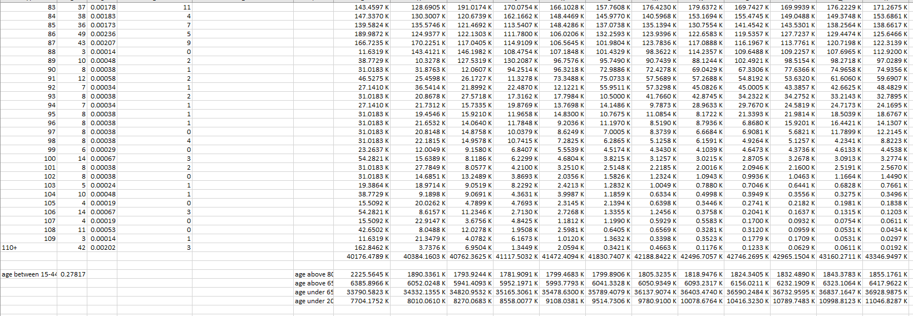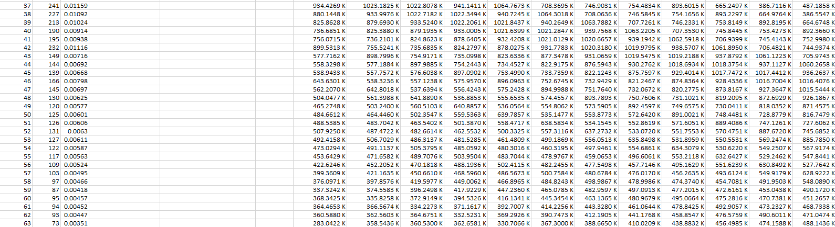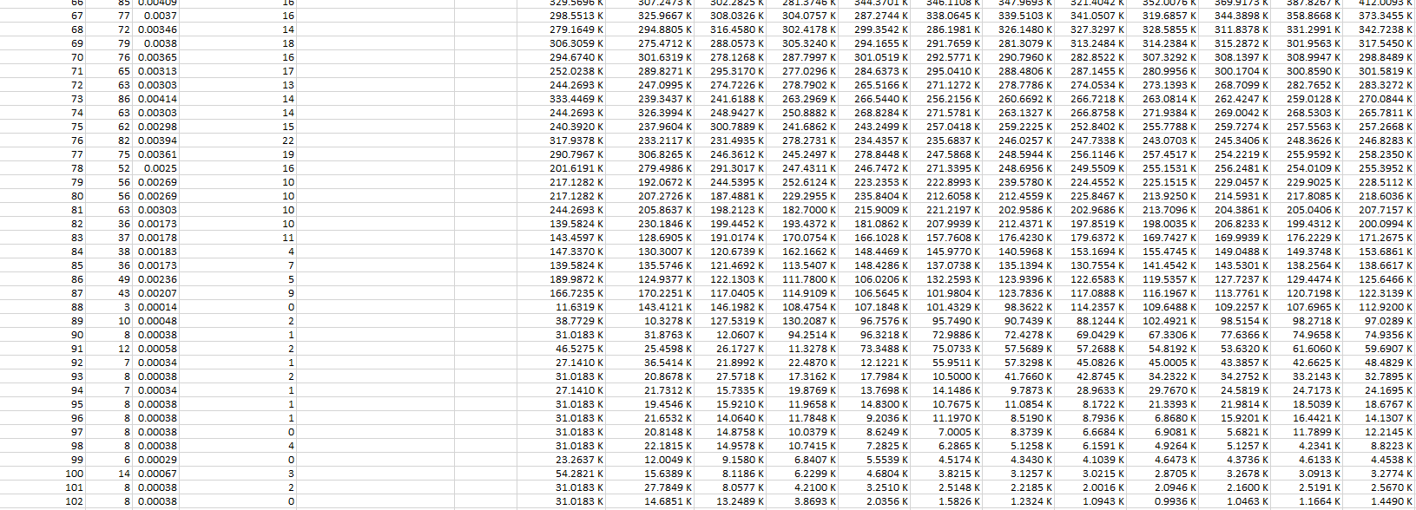**R code and screenshots**

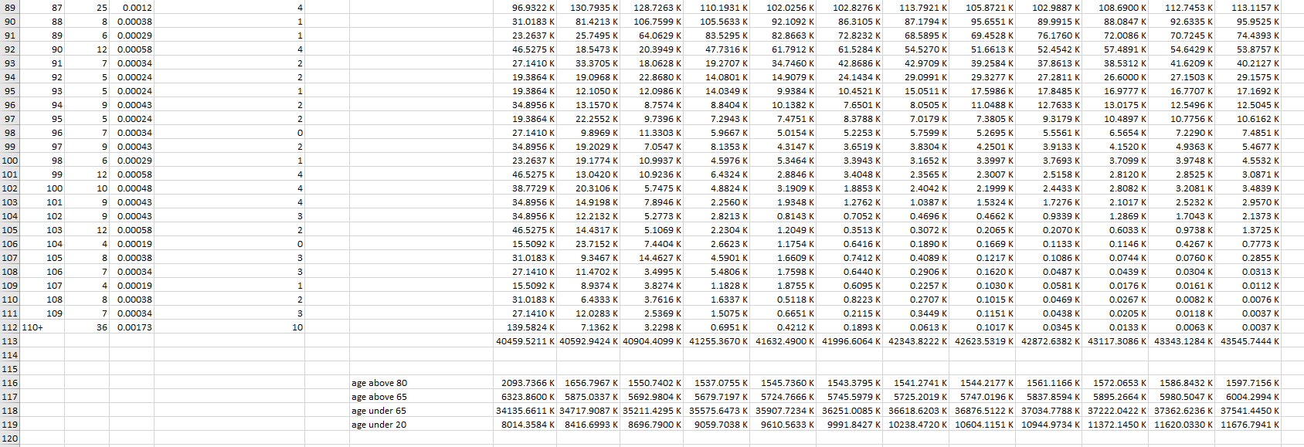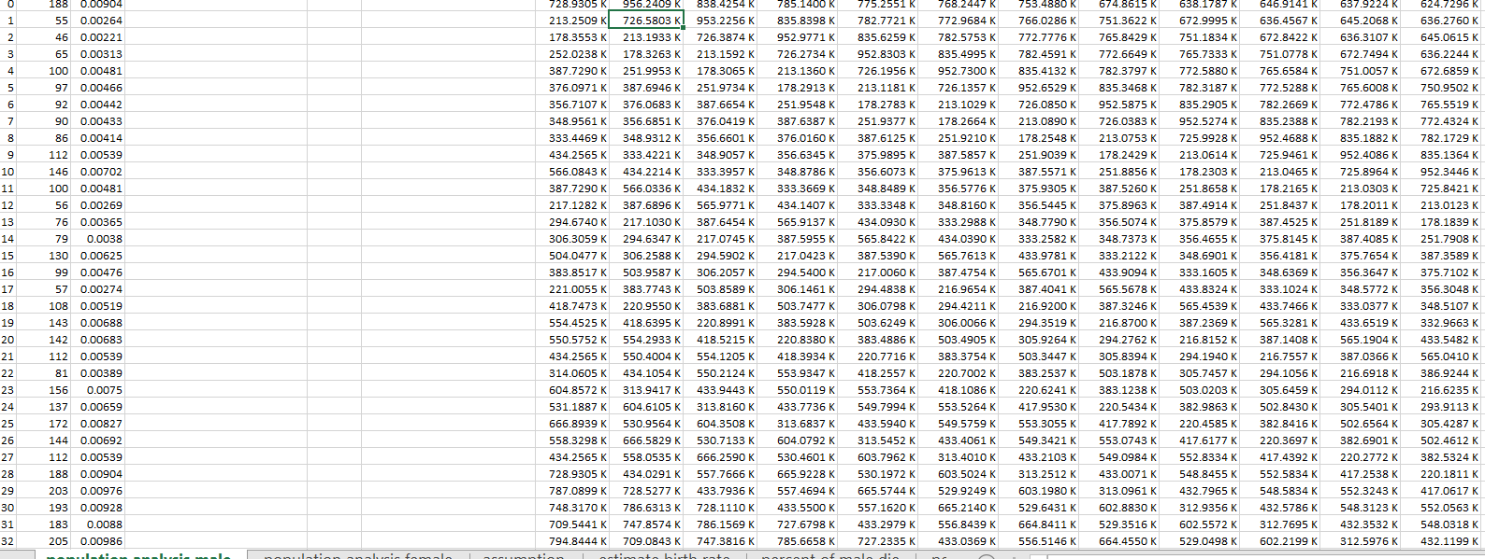

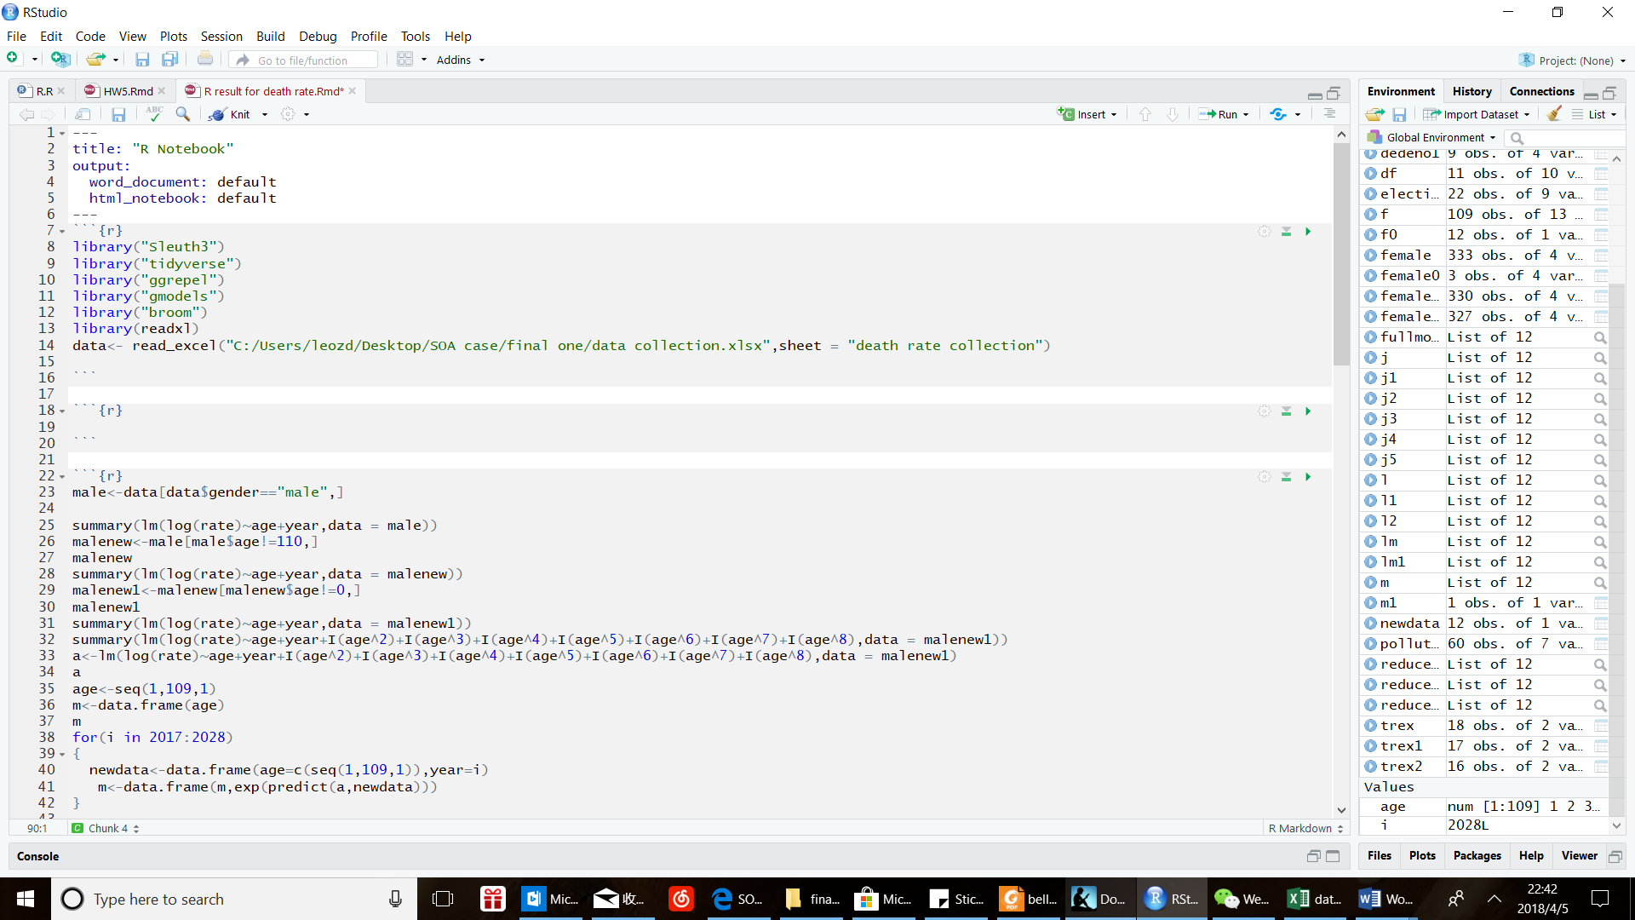(b) R code screen shot

